## Link to PM documentation

\\fatface.hq\fatface\Program Management\2.PRESENT\FFIT0131 General Data Protection (GDPR)\20 Project\FFIT0131-36 Hub Reports

New group

Role-AccidentReviewer

## Web page Navigation.

To launch IIS, go to Administrative tools. Right click on website and choose ‘Open’ to explore the files of the site in file explorer.

## Intraface.

Intraface 🡪 Health & safety 🡪 Accident Reporting

Has a new report button (top right on form) to create a new report

ff3web3 – D:\intraFace\intraface/htm (main page) includes a reference to contents.htm that defines the menu items on the Intraface landing page. The Link to Accident Reporting (below) points to the code for Web35Net/AccidentReporting website.

*<div class="Level_2" id='Menu_10.4' onmouseover="this.style.cursor='hand'" onclick="changeView('http://Web35Net/AccidentReporting/','','');">&nbsp;&nbsp;&nbsp;&nbsp;&nbsp;&nbsp;<img id="Image_10.4" src="/images/nomenuindicator.bmp" height="10px" width="10px">&nbsp;Accident Reporting*

*TODO Hide View, print and Full name on form.*

## The Hub

The Hub 🡪Departments🡪Health and Safety🡪 HO Accident Report

has a new report button (top right on form) to create a new Report

ffweb3 - D:\RootWeb\ASPapps\DropDownx\DropdownFiles\DeptDropDownMenu.html

This is the menu item file the DEPARTMENTS item points to from the main menu (Hub2.aspx also of ffweb3)  
The link points to the website on ffweb35net, this is where the code should be deployed and at present represents our latest version (pending source control)

*<a class="link" target=main onClick='javascript:redirect("DisplayWindow", "http://web35net/hoaccidentreport/reportlist.aspx");'>HO Accident Report</a>*

## Accident Log Excel Spreadsheet.

<http://testweb35net/AccidentLog/> = test  
<http://web35net/AccidentLog/> = Production.  
  
This needs to be in a secure location

## Database

The records for this report are held in   
FatIntraface.tblHO_HS_AccidentReport on the ffdbDev4\SQL4 instance

## Config Tasks.

1. Discover, get latest version of all code bases.
2. Document FatFace web architecture and servers.
3. Create project / repository in VSTS and add code

## Dev tasks

1. Remove / comment out ‘view’, ‘Print’, ’Full Name’ from forms / grids. on both Intraface and Hub
2. Change E-mail Link on mail that is sent when report submitted. This should now point to secure location (list of users allowed, perhaps AD group) where the report details can be viewed. <http://web35net/AccidentReporting/> This should be a secure location.

The link currently points to <http://web35net/HOAccidentReport/ReportList.aspx>  
This is configured in the web.config file lines 30-33

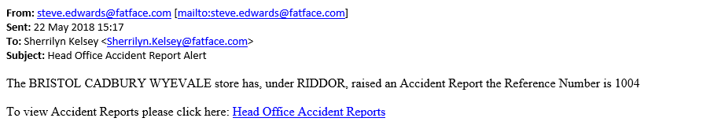  
  
Link currently goes to <http://testweb35net/HOAccidentReport/ReportList.aspx> or <http://web35net/HOAccidentReport/ReportList.aspx> if run from ‘live’ production

1. Create stored procedure to delete records from database that are older than 7 years  
   The field that holds the date of the accident (AccDate ) is not a datetime field but a Varchar(max) , therefore to do the date comparison and delete the following SQL statement was needed to convert the varchar to a datetime field, perform the comparison and delete if the conditions are met.  
   DELETE FROM Details_Test WHERE DATEADD(year,7 ,convert(DATETIME, String_Date,105)) < getdate()

1. Create SQL server Agent job to execute stored proc once a day.

## Testing – HUB HO Accident Report

1. One the Site is compiled successfully, copy the source directory to the   
   \\FFWEB35Net\TestWeb35Net\AspNet\HealthAndSafety\HOAccidentReport   
   back up the code that is there to an ‘archive’ directory at the same location.
2. View the test site with the following URL. http://testweb35net/hoaccidentreport/reportlist.aspx

**NB:** All email addresses must be configured for test recipients from within the project web.config file to avoid *spamming* other users with test data.

## Testing – Intraface

1. Once the site is compiled successfully, copy the source directory folder   
   \\FFWEB35Net\TestWeb35Net\AspNet\HealthAndSafety\AccidentReport
2. View the test site with the following URL <http://testweb35net/AccidentReporting/>

**NB:** All email addresses must be configured for test recipients from within the project web.config file to avoid *spamming* other users with test data.

## Testing – Removal of records older than 7 years

Notes :

For security , possibly Restrict access to the folder that holds the web site to view the details, via

Ad group hr for instance.